SUMANGAL ENTERPRISE
JAFARPUR PANCHANANTALA PATHAGAR ROAD PIN 700122

Residential Apartment Booked :- 04
Covered Parking Booked ;- 02
Basement Parking Booked :- NOT APLICABLE
Mechanical Parking Booked :- NOT APLICABLE
Building Construction Photo
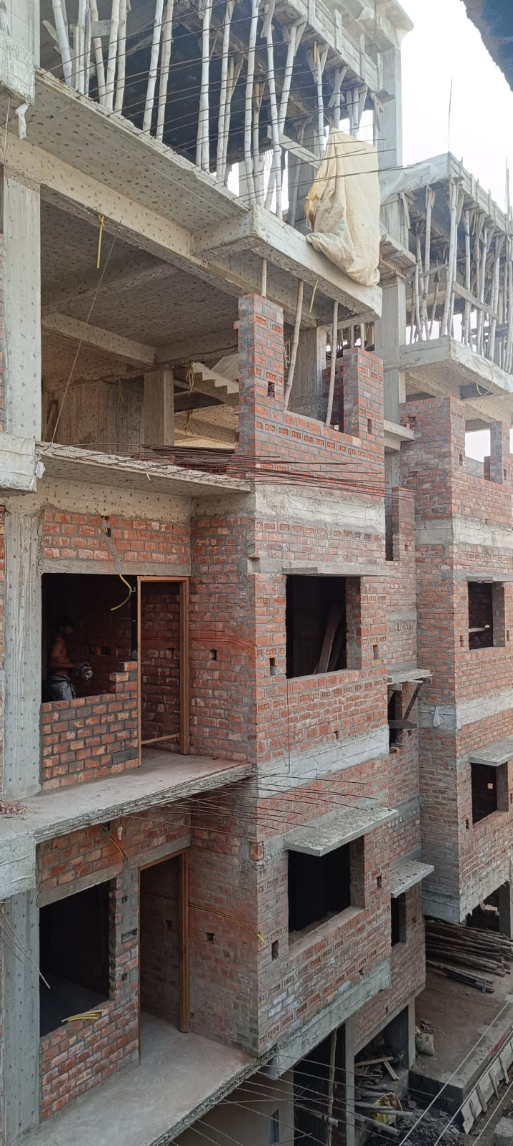
Internal Construction/Infrastructure Photo
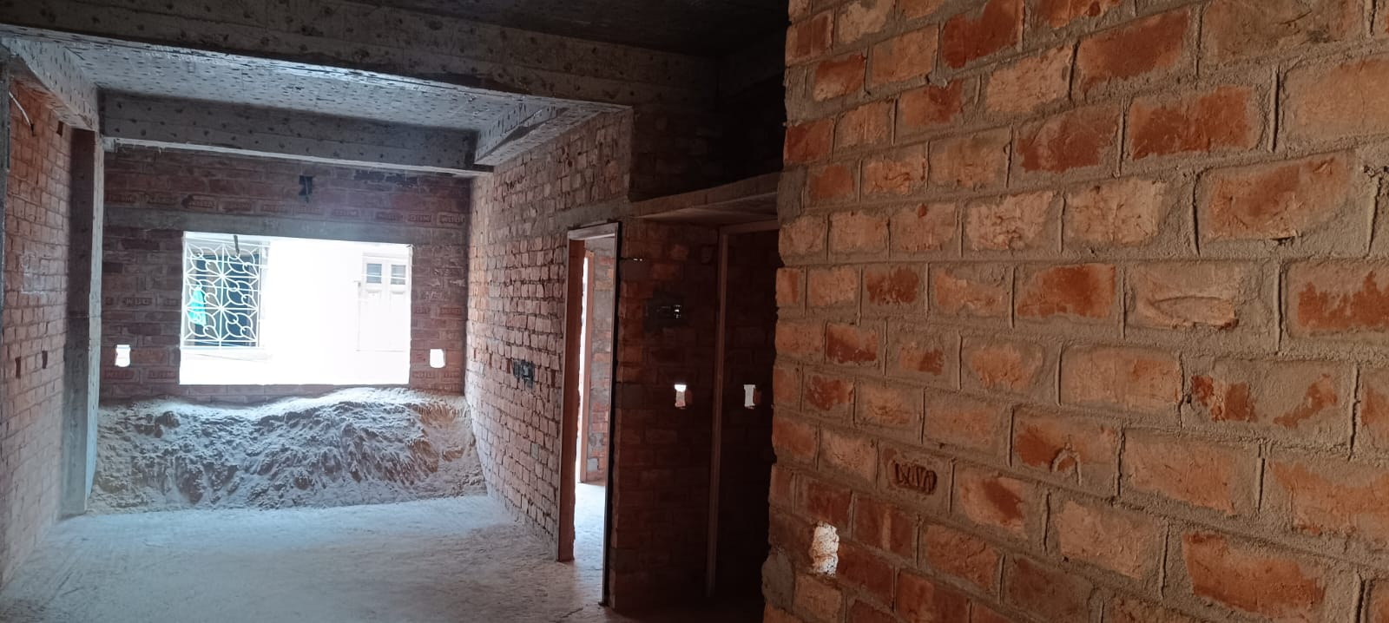
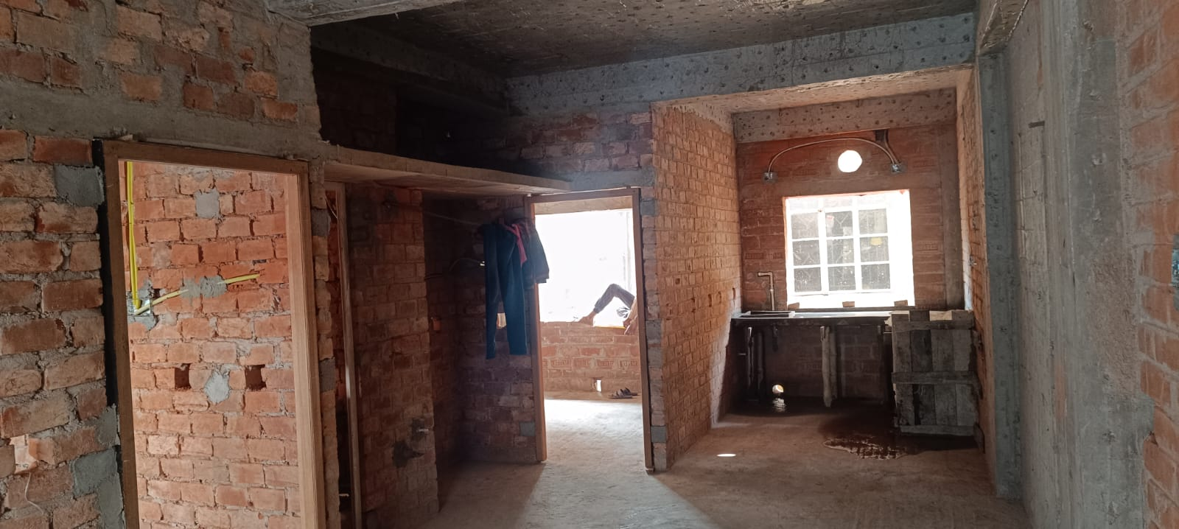

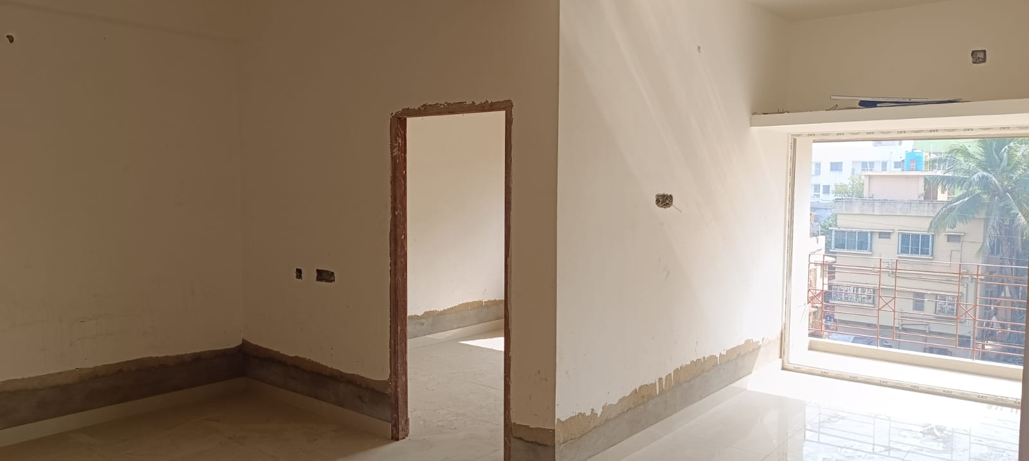
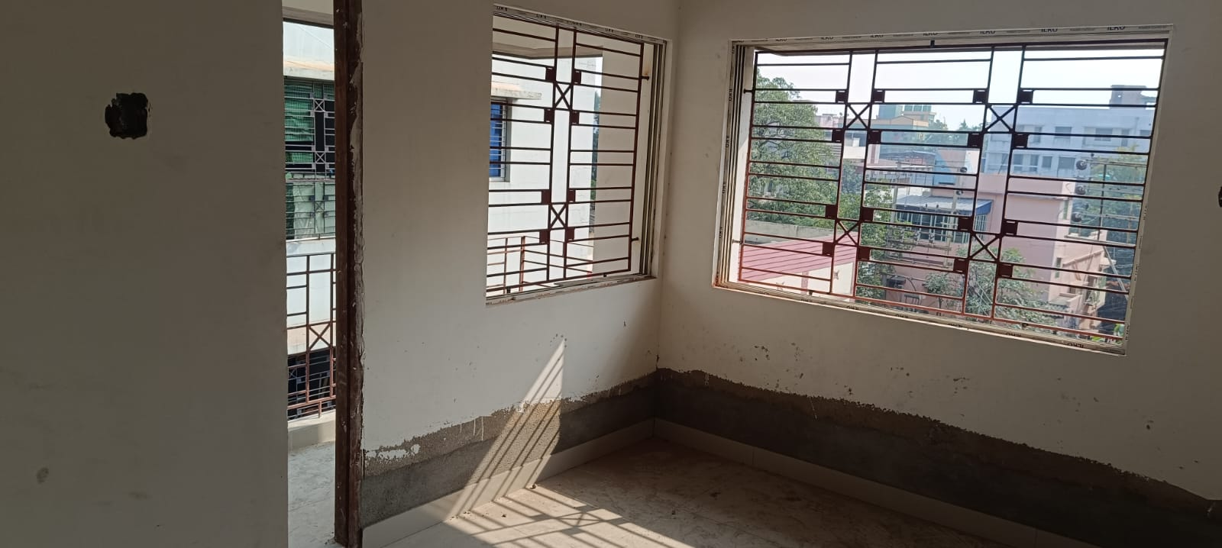

Common Area Photo
